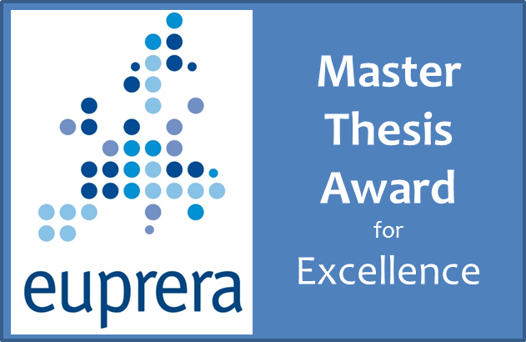

Application Form
Deadline February 27

Name Surname
e-mail address
Postal address

Title of dissertation
Dissertation completion date according to the university registry

University
City, country
Name of the MA, MSc or Mphil programme
Name Surname of the supervisor
Supervisor’s university (if different) or institution

Category which you are applying for (if applicable): Practical Impact or Theoretical Impact Award

Enquiries and submissions should be directed to the chair of the jury:

Alexander Buhmann
alexander.buhmann@bi.no

